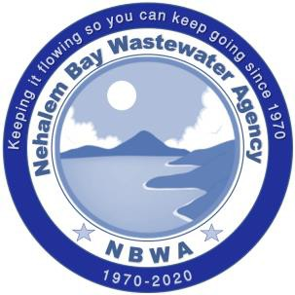



AGENDA

REGULAR MEETING OF THE BOARD OF DIRECTORS

**September 17, 2025 1:00 PM –NBWA Conference Room**

Zoom 1-669-900-6833 Meeting ID: 859 3988 7938 Passcode: 5125

1. WELCOME TO VISITORS
2. MINUTES
   1. Regular Meeting August 13, 2025
3. FINANCIAL REPORT
   1. For the month ending August 31, 2025
4. UNFINISHED BUSINESS
5. NEW BUSINESS
   1. Report to Board: Authorizing the Transfer of Appropriated Funds Within the FY25-26 General Fund Budget
      1. **RESOLUTION 2025-05:** AUTHORIZING THE TRANSFER OF APPROPRIATED FUNDS WITHIN THE FY25-26 GENERAL FUND BUDGET
   2. Report to Board: Request to Increase Single Signer Check Limit
      1. **RESOLUTION 2025-06:** INCREASING THE SINGLE SIGNER CHECK LIMIT FROM $500 TO $750
   3. USBank Documents: Continued effort to change US Bank Signatories and Treasury Management. (Approved by the Board 5/21/25).
6. MANAGER’S REPORT
   1. Projects Update
   2. EVCNB MOU
7. BOARD COMMENTS
8. PUBLIC COMMENTS

To join the meeting through Zoom: email info@nbwaor.gov for video zoom invite

35755 Seventh/PO Box 219 Nehalem Oregon 97131-0219 phone (503)368-5125 fax (503)368-7211