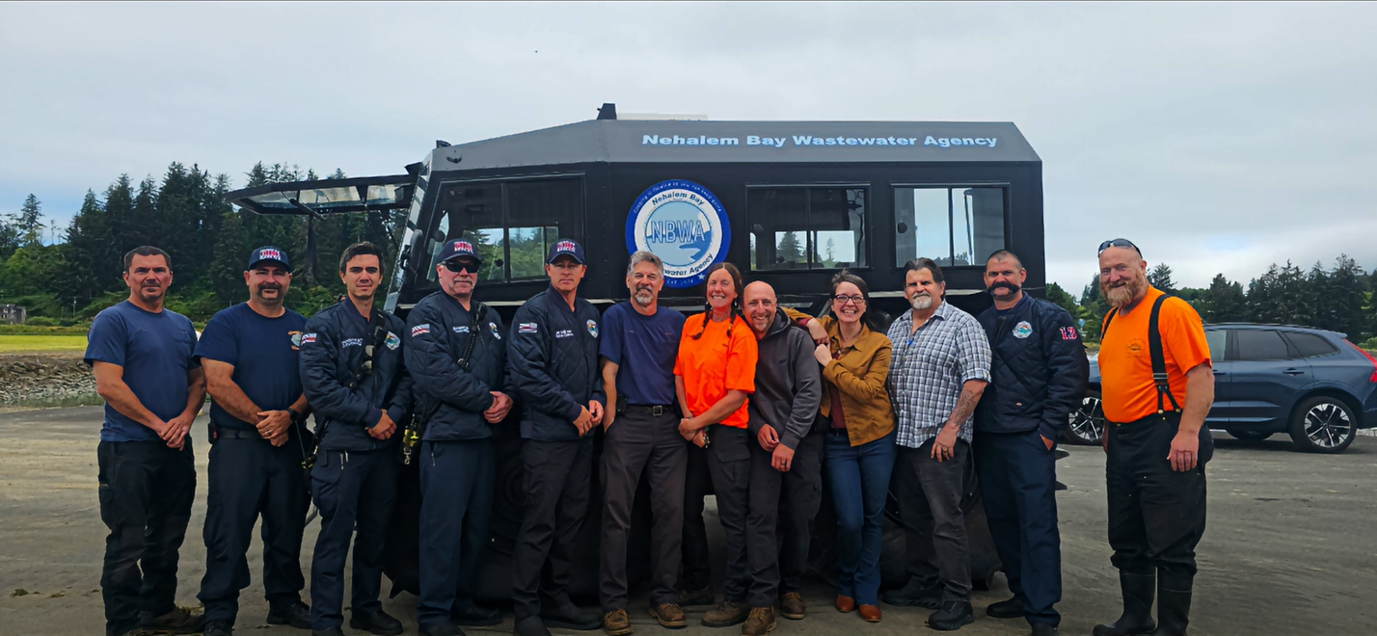Nehalem Bay Wastewater Agency Enhances Regional Emergency Preparedness with Amphibious Utility Vehicle
NEHALEM, OR — July 10, 2026 — In a proactive move to safeguard public health and critical infrastructure during severe weather events, the Nehalem Bay Wastewater Agency (NBWA) has announced the acquisition of a specialized, all-terrain amphibious utility vehicle. The acquisition
marks the latest milestone in the Agency's long-standing dedication to emergency preparedness and collaborative resource-sharing with North Oregon Coast first responders.
For decades, NBWA has prioritized resilient infrastructure through a consistent, sustainable, and long-term financial model: operating entirely without the need for bonds or loans. By strictly adhering to a comprehensive 25-year master plan and operating entirely within the confines of its annual budget, the Agency ensures that the majority of regular user fees are dedicated directly to system development and capital improvements rather than interest payments.
This disciplined fiscal approach is what allowed NBWA to design and fund emergency septic systems for the three local cities: Nehalem, Manzanita, and Wheeler. While Nehalem and Wheeler have successfully installed their systems, Manzanita is currently in the planning stages for completion. The newly acquired amphibious vehicle builds directly upon this legacy of preparedness. Unlike a traditional watercraft or airboat—which requires a trailer, a functional boat launch, and is strictly confined to open waterways—the amphibious SHERP can seamlessly transition from land to water. This unique capability allows operators to traverse flooded roads, marshy utility easements, and open water alike, ensuring access to critical main lines and treatment facilities during a catastrophic coastal disaster when standard fleet vehicles and traditional boats are grounded.
Crucially, this specialized piece of equipment was acquired through strategic asset management rather than a burden to local taxpayers. The purchase was uniquely viable due to a $100,000 surplus sale of older, retired equipment, which directly offset the majority of the acquisition cost.
Furthermore, because of its commitment to debt-free operations, NBWA proudly maintains one of the lowest wastewater rates in the State of Oregon and remains intensely focused on keeping rates low for its customers while maintaining a high standard of utility resilience and modern safety capabilities.
True to NBWA's spirit of regional partnership, the vehicle will serve as a shared community resource. Yesterday, NBWA hosted Nehalem Bay Fire & Rescue for a hands-on joint training session on land and in the river to ensure local emergency personnel are fully familiarized with the vehicle’s capabilities. Building on this collaborative effort, NBWA is expanding its regional training initiatives and has invited the Emergency Volunteer Corps of Nehalem Bay, the Tillamook County Sheriff's Search and Rescue team, and the Manzanita Police Department to participate in the next multi-agency training session scheduled for August. In the event of a severe coastal disaster, the vehicle will be fully available to support these local first responders in critical rescue and recovery operations.
"Our primary mission is to protect public health and the environment, which requires being ready for the absolute worst-case weather scenarios the Oregon Coast can throw at us," said Keri Scott, Executive Assistant at NBWA. "By leveraging surplus equipment sales and staying true to our decades-long tradition of operating debt-free within our master plan, we secured a vital piece of disaster-response machinery without impacting our rates. We are proud to share this resource with our local fire and rescue partners to ensure our entire community is safer and more resilient."
For more information regarding the Nehalem Bay Wastewater Agency's emergency preparedness initiatives or to review upcoming board meeting agendas, please visit nbwaor.gov or attend the monthly public board meetings.

